Assignment 1

Name: Aditya Sawant

Roll No: 31302

Topic: Restaurant Management

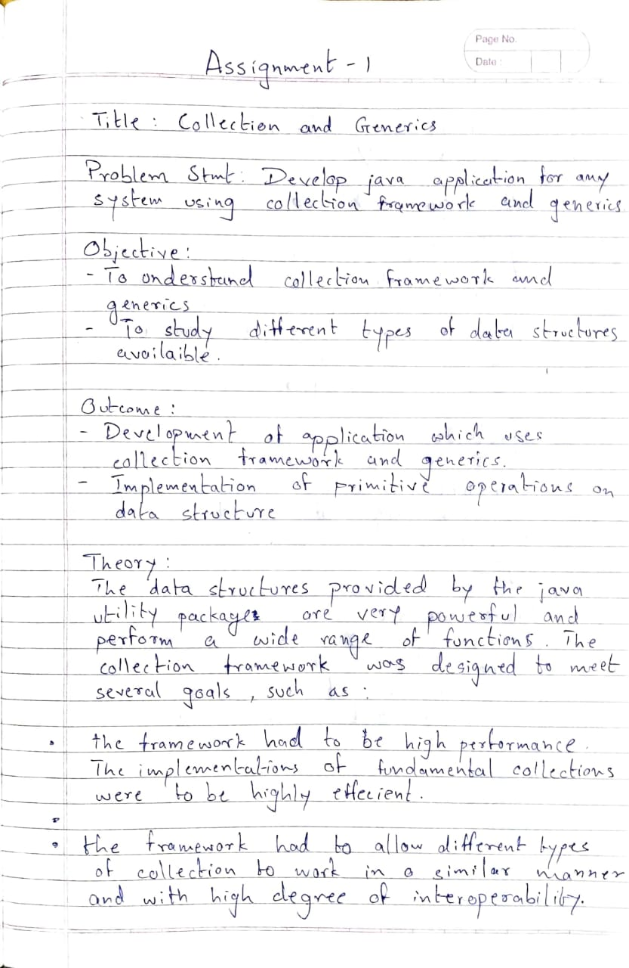

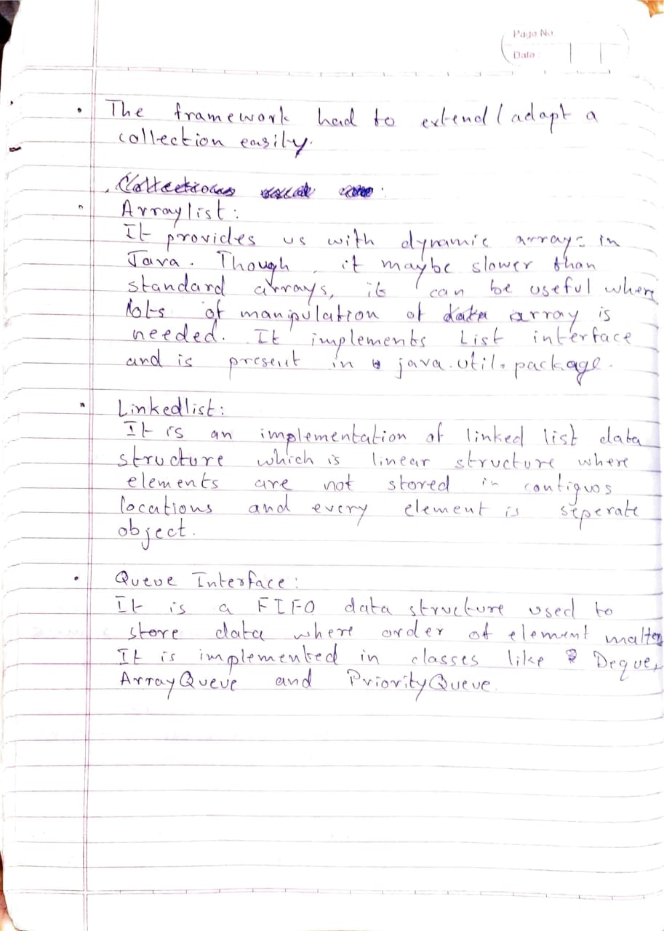

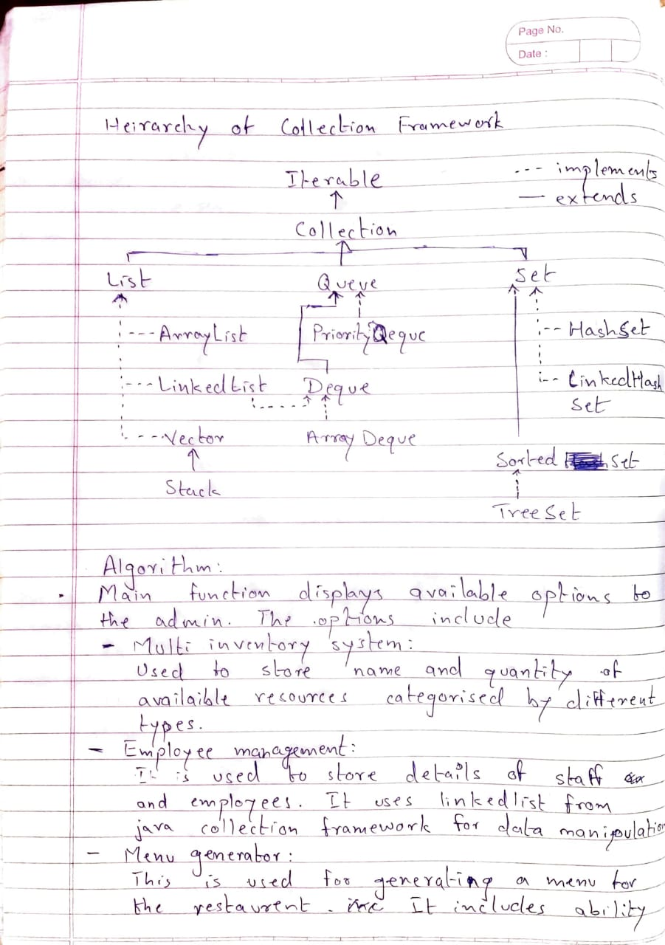

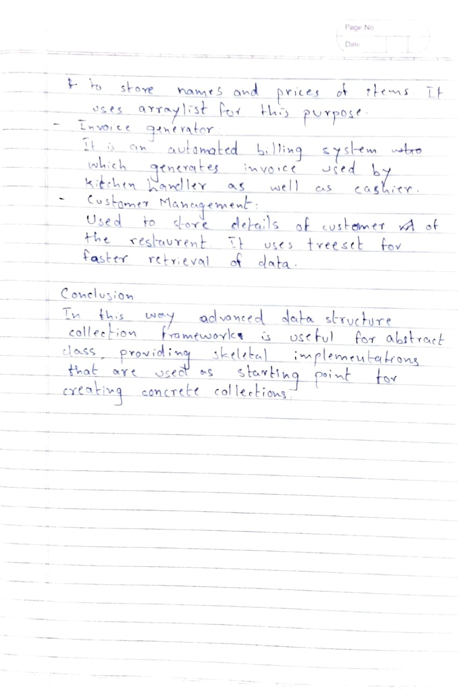

Code:

import java.util.\*;

import java.io.\*;

import java.net.\*;

class InventoryManagement

{

class Inventory

{

class InventoryItem

{

String itemName;

int itemQuantity;

InventoryItem(){}

InventoryItem(String name, int qty)

{

itemName = name;

itemQuantity = qty;

}

}

ArrayList<InventoryItem> inventory = new ArrayList<InventoryItem>();

String inventoryName;

Scanner sc = new Scanner(System.in);

Inventory(String name)

{

inventoryName = name;

}

Inventory(){}

void createList()

{

while(true)

{

System.out.println("Enter item name: ");

String itemName = sc.nextLine();

if(itemName.equals("stop"))

{

return;

}

System.out.println("Enter item quantity: ");

int itemQuantity = sc.nextInt();

sc.nextLine();

inventory.add(new InventoryItem(itemName, itemQuantity));

}

}

void addItem()

{

InventoryItem obj = new InventoryItem();

System.out.println("Enter item name: ");

obj.itemName = sc.nextLine();

System.out.println("Enter item quantity: ");

obj.itemQuantity = sc.nextInt();

inventory.add(obj);

}

void deleteItem()

{

System.out.println("Enter item to be deleted: ");

String name = sc.nextLine();

for(int i=0; i<inventory.size(); i++)

{

if(name.equals(inventory.get(i).itemName))

{

inventory.remove(i);

}

}

}

void updateInventory()

{

System.out.println("Enter item to be updated: ");

String name = sc.nextLine();

System.out.println("Enter new quantity: ");

int qty = sc.nextInt();

for(int i=0; i<inventory.size(); i++)

{

if(name.equals(inventory.get(i).itemName))

{

inventory.remove(i);

inventory.add(i, new InventoryItem(name, qty));

return;

}

}

}

void displayInventory()

{

System.out.println("------------------");

System.out.println("|Name\t|Quantity|");

System.out.println("------------------");

for(InventoryItem item: inventory)

{

System.out.println("|" + item.itemName + "\t|" + item.itemQuantity + " |");

System.out.println("------------------");

}

}

void displayMenu()

{

System.out.println("");

System.out.println("\*\*\*\*Inventory Options\*\*\*\*");

System.out.println("Current inventory: " + inventoryName);

System.out.println("1. Add new item");

System.out.println("2. Delete an item");

System.out.println("3. Update inventory");

System.out.println("4. Display inventory");

System.out.println("5. Back");

int choice = 0;

while(true)

{

try

{

System.out.println("Enter choice: ");

choice = sc.nextInt();

sc.nextLine();

switch(choice)

{

case 1:

addItem();

break;

case 2:

deleteItem();

break;

case 3:

updateInventory();

break;

case 4:

displayInventory();

break;

case 5:

return;

default:

System.out.println("Invalid choice.");

}

}

catch(InputMismatchException e)

{

System.out.println("Invalid input. Please try again.");

sc.nextLine();

}

}

}

}

ArrayList<Inventory> list = new ArrayList<Inventory>();

Scanner sc = new Scanner(System.in);

int currentList;

void createNewList()

{

System.out.println("Enter inventory name: ");

String name = sc.nextLine();

list.add(new Inventory(name));

list.get(list.size()-1).createList();

}

void displayList()

{

if(list.size() == 0)

{

System.out.println("No list present. Please add a list.");

return;

}

System.out.println("");

System.out.println("\*\*\*\*Current Lists\*\*\*\*");

for(int i=0; i<list.size(); i++)

{

System.out.println((i+1) + ". " + list.get(i).inventoryName);

}

System.out.println("Select list: ");

currentList = sc.nextInt()-1;

System.out.println("Selected " + list.get(currentList).inventoryName + ". Please select an operation.");

}

void updateList()

{

list.get(currentList).displayMenu();

}

void deleteList()

{

list.remove(currentList);

}

void inventoryManagementMenu()

{

System.out.println("");

System.out.println("\*\*\*\*Inventory Management\*\*\*\*");

System.out.println("1. Create new list");

System.out.println("2. Display lists");

System.out.println("3. Update list");

System.out.println("4. Delete list");

System.out.println("5. Back");

int choice = 0;

while(true)

{

try

{

System.out.println("Enter choice: ");

choice = sc.nextInt();

sc.nextLine();

switch(choice)

{

case 1:

createNewList();

break;

case 2:

displayList();

break;

case 3:

updateList();

break;

case 4:

deleteList();

break;

case 5:

return;

default:

System.out.println("Invalid choice.");

}

}

catch(InputMismatchException e)

{

System.out.println("Invalid input. Please try again.");

sc.nextLine();

}

catch(IndexOutOfBoundsException e)

{

System.out.println("Error 404: List not found.");

}

}

}

}

class EmployeeManagement

{

class EmployeeDetails

{

String name;

int age;

long phoneNo;

String designation;

String address;

}

LinkedList<EmployeeDetails> employeeList= new LinkedList<EmployeeDetails>();

Scanner sc = new Scanner(System.in);

void insertRecord()

{

EmployeeDetails obj = new EmployeeDetails();

System.out.print("Name: ");

obj.name = sc.nextLine();

System.out.print("Age: ");

obj.age = sc.nextInt();

System.out.print("Phone No: ");

obj.phoneNo = sc.nextInt();

sc.nextLine();

System.out.print("Designation: ");

obj.designation = sc.nextLine();

System.out.print("Address: ");

obj.address = sc.nextLine();

employeeList.add(obj);

}

void displayRecords()

{

System.out.println("");

System.out.println("\*\*\*\*Employee List\*\*\*\*");

System.out.println("Name | Age | Phone No | Designation | Address");

for(EmployeeDetails obj: employeeList)

{

System.out.println(obj.name + " | " + obj.age + " | " + obj.phoneNo + " | " + obj.designation + " | " + obj.address);

}

}

void updateRecord()

{

System.out.print("Enter name of employee to be updated: ");

String name = sc.nextLine();

int i;

for(i=0; i<employeeList.size(); i++)

{

if(name.equals(employeeList.get(i).name))

{

break;

}

}

if(i == employeeList.size())

{

System.out.println("Error 404: Record not found.");

return;

}

System.out.println("Choose data to be updated: ");

System.out.println("1. Name");

System.out.println("2. Age");

System.out.println("3. Phone number");

System.out.println("4. Designation");

System.out.println("5. Address");

System.out.println("6. Back");

while(true)

{

System.out.print("Enter choice: ");

int choice = sc.nextInt();

System.out.print("Enter updated data: ");

sc.nextLine();

String data = sc.nextLine();

switch(choice)

{

case 1:

employeeList.get(i).name = data;

break;

case 2:

employeeList.get(i).age = Integer.parseInt(data);

break;

case 3:

employeeList.get(i).phoneNo = Integer.parseInt(data);

break;

case 4:

employeeList.get(i).designation = data;

break;

case 5:

employeeList.get(i).address = data;

break;

case 6:

return;

default:

System.out.println("Invalid choice.");

}

}

}

/\*<E> void newValue(int i, E data)

{

if(i == 2 || i == 3)

{

}

}\*/

void deleteRecord()

{

System.out.print("Enter name of employee to be updated: ");

String name = sc.nextLine();

int i;

for(i=0; i<employeeList.size(); i++)

{

if(name.equals(employeeList.get(i).name))

{

employeeList.remove(i);

}

}

if(i == employeeList.size())

{

System.out.println("Error 404: Record not found.");

return;

}

else

{

System.out.println("Record deleted.");

}

}

void employeeManagementMenu()

{

System.out.println("");

System.out.println("\*\*\*\*Employee Management\*\*\*\*");

System.out.println("1. Insert record");

System.out.println("2. Display records");

System.out.println("3. Update record");

System.out.println("4. Delete record");

System.out.println("5. Back");

while(true)

{

System.out.print("Enter choice: ");

int choice = sc.nextInt();

sc.nextLine();

switch(choice)

{

case 1:

insertRecord();

break;

case 2:

displayRecords();

break;

case 3:

updateRecord();

break;

case 4:

deleteRecord();

break;

case 5:

return;

default:

System.out.println("Invalid choice.");

}

}

}

}

class MenuGenerator

{

class MenuItem

{

String name;

int price;

MenuItem(String n,int p)

{

name = n;

price = p;

}

}

Scanner sc = new Scanner(System.in);

ArrayList<MenuItem> menu = new ArrayList<MenuItem>();

void createMenuList()

{

while(true)

{

System.out.print("Item name: ");

String name = sc.nextLine();

if(name.equals("stop"))

{

return;

}

System.out.print("Item price: ");

int price = sc.nextInt();

sc.nextLine();

menu.add(new MenuItem(name, price));

}

}

void displayMenuItems()

{

System.out.println("\*\*\*\*Food Menu\*\*\*\*");

System.out.println("Item Name Price");

for(MenuItem m : menu)

{

System.out.println(m.name + " " + m.price);

}

}

void addMenuItem()

{

System.out.print("Item name: ");

String name = sc.nextLine();

System.out.print("Item price: ");

int price = sc.nextInt();

sc.nextLine();

menu.add(new MenuItem(name, price));

}

void deleteMenuItem()

{

String name;

System.out.print("Enter name of item to be deleted: ");

name = sc.nextLine();

for(int i=0; i<menu.size(); i++)

{

if(name.equals(menu.get(i).name))

{

menu.remove(i);

}

}

}

void menuGenerator()

{

System.out.println("");

System.out.println("\*\*\*\*Menu Generator\*\*\*\*");

System.out.println("1. Create menu");

System.out.println("2. Display menu");

System.out.println("3. Add menu item");

System.out.println("4. Delete menu item");

System.out.println("5. Back");

while(true)

{

System.out.print("Enter choice: ");

int choice = sc.nextInt();

sc.nextLine();

switch(choice)

{

case 1:

createMenuList();

break;

case 2:

displayMenuItems();

break;

case 3:

addMenuItem();

break;

case 4:

deleteMenuItem();

break;

case 5:

return;

default:

System.out.println("Invalid choice.");

}

}

}

}

class Invoice

{

String customerName;

int tableNo;

HashMap<String,Integer> orderDetails = new HashMap<String,Integer>();

Invoice(){}

Invoice(String name, int table, HashMap<String,Integer> obj)

{

customerName = name;

tableNo = table;

orderDetails = obj;

}

}

class InvoiceGenerator

{

Scanner sc = new Scanner(System.in);

LinkedList<Invoice> customerList = new LinkedList<Invoice>();

KitchenHandler kh;

InvoiceGenerator(KitchenHandler obj)

{

kh = obj;

}

void createInvoice()

{

System.out.print("Enter customer name: ");

String name = sc.nextLine();

System.out.print("Enter table number: ");

int tableNo = sc.nextInt();

sc.nextLine();

HashMap<String,Integer> orderDetails = new HashMap<String,Integer>();

while(true)

{

System.out.print("Item name: ");

String itemName = sc.nextLine();

if(itemName.equals("stop"))

{

break;

}

System.out.print("Item quantity: ");

int itemQty = sc.nextInt();

sc.nextLine();

orderDetails.put(itemName,itemQty);

}

Invoice invoice = new Invoice(name,tableNo,orderDetails);

customerList.add(invoice);

kh.addNewOrder(invoice);

}

void deleteInvoice()

{

System.out.println("Enter table no: ");

int tblNo = sc.nextInt();

int i;

for(i=0; i<customerList.size(); i++)

{

if(tblNo == customerList.get(i).tableNo)

{

customerList.remove(i);

}

}

if(i == customerList.size())

{

System.out.println("Error 404: Customer not found.");

}

}

void displayCustomerQueue()

{

if(customerList.size() == 0)

{

System.out.println("No records present.");

return;

}

for(Invoice obj : customerList)

{

System.out.println("Name: " + obj.customerName);

System.out.println("Table No: " + obj.tableNo);

for(Map.Entry m : obj.orderDetails.entrySet()){

System.out.println(m.getKey()+" "+m.getValue());

}

}

}

KitchenHandler invoiceGeneratorMenu()

{

while(true)

{

try

{

System.out.println("");

System.out.println("\*\*\*\*Invoice Generator\*\*\*\*");

System.out.println("1. New Invoice");

System.out.println("2. Display Invoice");

System.out.println("3. Delete Invoice");

System.out.println("4. Back");

System.out.print("Enter choice: ");

int choice = sc.nextInt();

sc.nextLine();

switch(choice)

{

case 1:

createInvoice();

break;

case 2:

displayCustomerQueue();

break;

case 3:

deleteInvoice();

break;

case 4:

return kh;

default:

System.out.println("Invalid choice.");

}

}

catch(InputMismatchException e)

{

System.out.println("Error: Wrong input type. Please try again.");

sc.nextLine();

}

}

}

}

class KitchenHandler

{

Queue<Invoice> orderQueue = new LinkedList<Invoice>();

Scanner sc = new Scanner(System.in);

void addNewOrder(Invoice obj)

{

orderQueue.add(obj);

}

void displayOrderQueue()

{

System.out.println("");

System.out.println("\*\*\*\*Order Queue\*\*\*\*");

for(Invoice obj : orderQueue)

{

System.out.println("Name: " + obj.customerName);

System.out.println("Table No: " + obj.tableNo);

for (Map.Entry m : obj.orderDetails.entrySet()) {

System.out.println(m.getKey() + " " + m.getValue());

}

}

}

void kitchenHandlerMenu()

{

while(true)

{

System.out.println("");

System.out.println("\*\*\*\*Kitchen Handler\*\*\*\*");

System.out.println("1. Display order queue");

System.out.println("2. Request service");

System.out.println("3. Back");

System.out.print("Enter choice: ");

int choice = sc.nextInt();

switch(choice)

{

case 1:

displayOrderQueue();

break;

case 2:

orderQueue.remove();

break;

case 3:

return;

default:

System.out.println("Invalid choice.");

}

}

}

class CustomerHandler extends CustomerDetails

{

class CustomerDetails implements Comparable<CustomerDetails>

{

String custName;

long custPhoneNo;

String custAddress;

CustomerDetails(){}

CustomerDetails(String name, int phoneNo, String address)

{

custName = name;

custPhoneNo = phoneNo;

custAddress = address;

}

public int compareTo(CustomerDetails cd)

{

return this.custName.compareTo(cd.custName);

}

}

TreeSet<CustomerDetails> customerList = new TreeSet<CustomerDetails>();

Scanner sc = new Scanner(System.in);

void newCustomer()

{

//CustomerDetails obj = new CustomerDetails();

System.out.print("Name: ");

String custName = sc.nextLine();

System.out.print("Phone No: ");

int custPhoneNo = sc.nextInt();

sc.nextLine();

System.out.print("Address: ");

String custAddress = sc.nextLine();

customerList.add(new CustomerDetails(custName, custPhoneNo, custAddress));

}

void updateCustomer()

{

System.out.print("Name: ");

String name = sc.nextLine();

CustomerDetails temp = new CustomerDetails();

for(CustomerDetails obj : customerList)

{

if(obj.custName.equals(name))

{

temp = obj;

customerList.remove(obj);

}

}

System.out.print("1. Name");

System.out.print("2. Phone No");

System.out.print("3. Address");

System.out.print("Enter choice: ");

int choice = sc.nextInt();

switch(choice)

{

case 1:

System.out.print("Enter new name: ");

temp.custName = sc.nextLine();

break;

case 2:

System.out.print("Enter new phone number: ");

temp.custPhoneNo = sc.nextInt();

break;

case 3:

System.out.print("Enter new address: ");

temp.custAddress = sc.nextLine();

break;

default:

System.out.println("Invalid choice.");

}

customerList.add(temp);

}

void deleteCustomer()

{

System.out.print("Name: ");

String name = sc.nextLine();

for(CustomerDetails obj : customerList)

{

if(obj.custName.equals(name))

{

customerList.remove(obj);

}

}

}

void displayCustomers()

{

for(CustomerDetails obj : customerList)

{

System.out.println(obj.custName + " " + obj.custPhoneNo + " " + obj.custAddress);

}

}

void customerHandlerMenu()

{

while(true)

{

try

{

System.out.println("");

System.out.println("\*\*\*\*Customer Management\*\*\*\*");

System.out.println("1. New customer");

System.out.println("2. Display customers");

System.out.println("3. Update customer");

System.out.println("4. Delete customer");

System.out.println("5. Back");

System.out.print("Enter choice: ");

int choice = sc.nextInt();

sc.nextLine();

switch(choice)

{

case 1:

newCustomer();

break;

case 2:

displayCustomers();

break;

case 3:

updateCustomer();

break;

case 4:

deleteCustomer();

break;

case 5:

return;

default:

System.out.println("Invalid choice.");

}

}

catch(InputMismatchException e)

{

System.out.println("Error: Wrong input type. Please try again.");

sc.nextLine();

}

}

}

}

class MyClass

{

public static void main(String[] args)

{

InventoryManagement invMgmt = new InventoryManagement();

EmployeeManagement empMgmt = new EmployeeManagement();

MenuGenerator menuGen = new MenuGenerator();

CustomerHandler custHandler = new CustomerHandler();

KitchenHandler kh = new KitchenHandler();

InvoiceGenerator invoiceGen = new InvoiceGenerator(kh);

while(true)

{

try

{

System.out.println("");

System.out.println("\*\*\*\*Restaurant Management\*\*\*\*");

System.out.println("1. Inventory Management");

System.out.println("2. Employee Management");

System.out.println("3. Menu Generator");

System.out.println("4. Invoice Generator");

System.out.println("5. Customer Management");

System.out.println("6. Kitchen Handler");

System.out.println("7. Exit");

System.out.print("Enter choice: ");

Scanner sc = new Scanner(System.in);

int choice = sc.nextInt();

switch(choice)

{

case 1:

invMgmt.inventoryManagementMenu();

break;

case 2:

empMgmt.employeeManagementMenu();

break;

case 3:

menuGen.menuGenerator();

break;

case 4:

kh = invoiceGen.invoiceGeneratorMenu();

break;

case 5:

custHandler.customerHandlerMenu();

break;

case 6:

kh.kitchenHandlerMenu();

break;

case 7:

return;

default:

System.out.println("Invalid input.");

}

}

catch(InputMismatchException e)

{

System.out.println("Error: Wrong input type. Please try again.");

}

}

}

}

Screenshots of output:

Inventory Management: 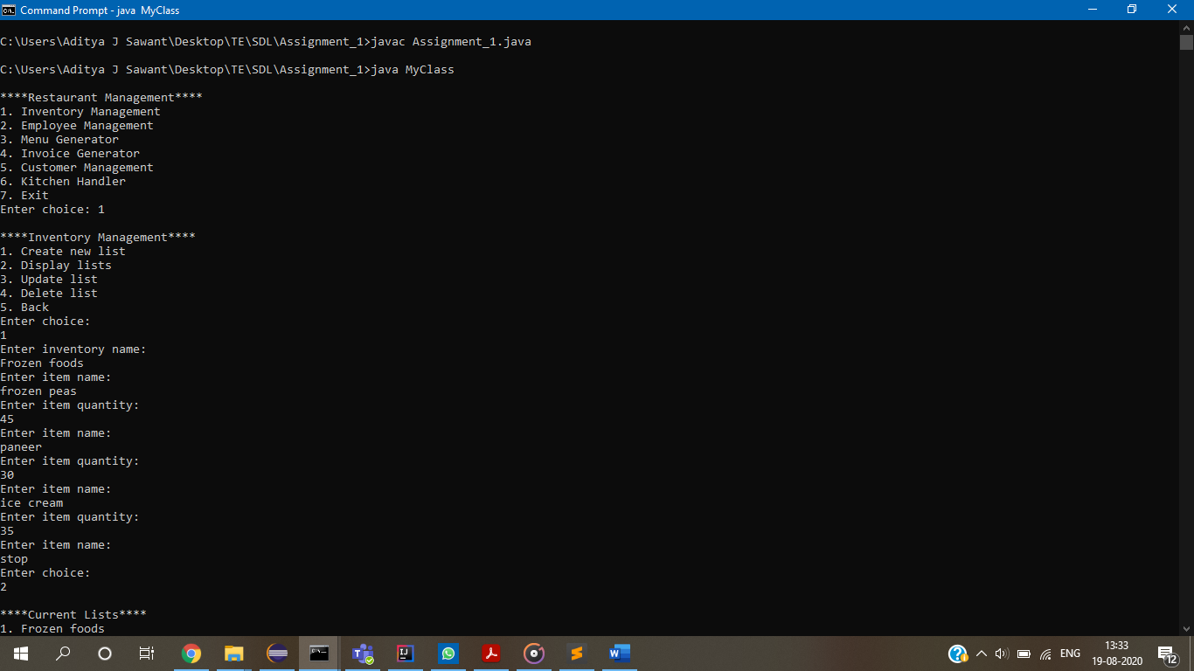

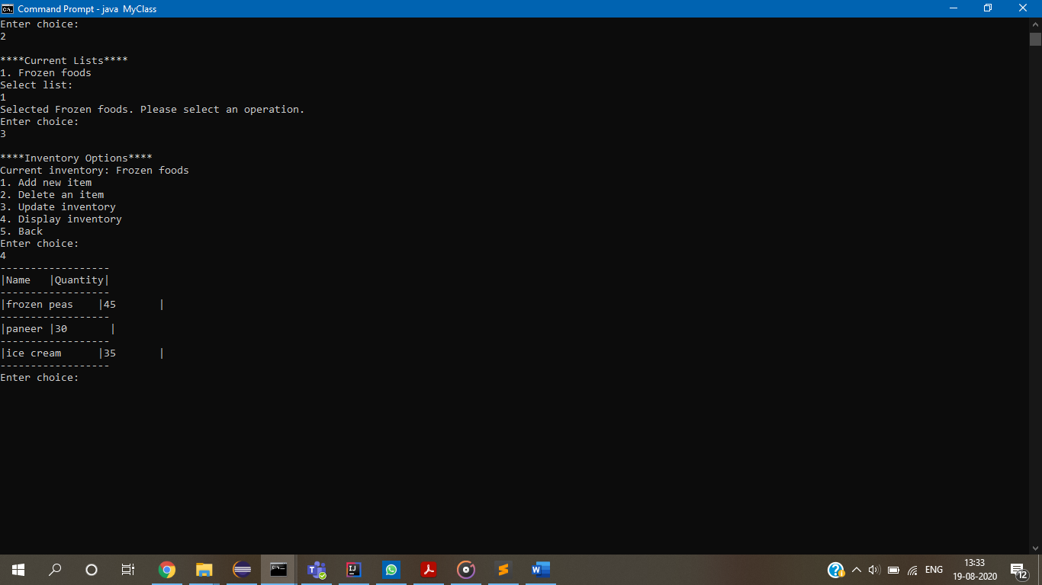

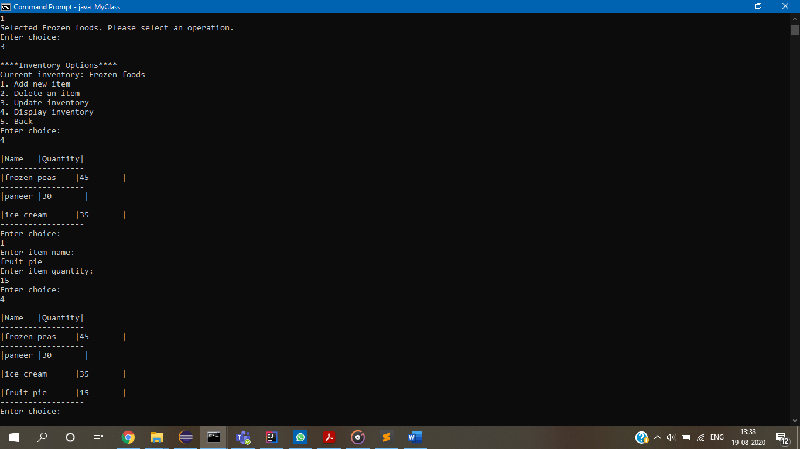

Employee Management:

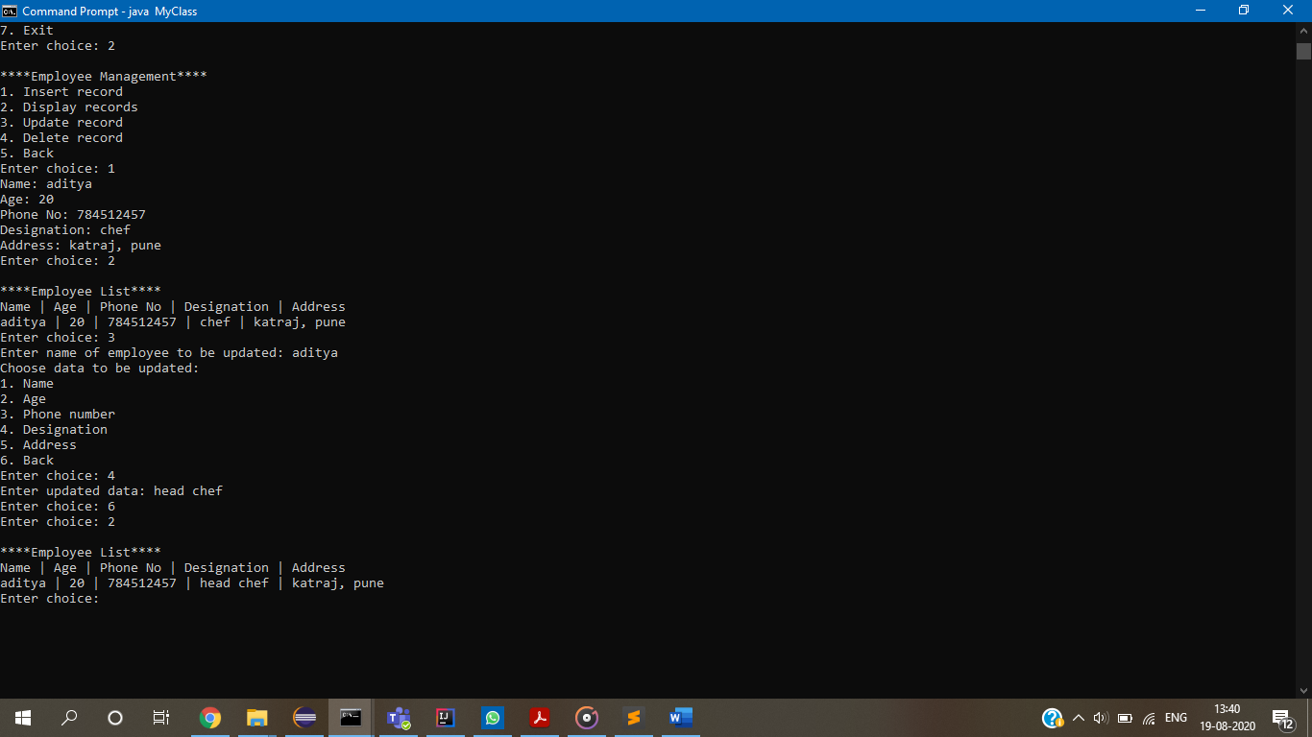

Invoice Generator: 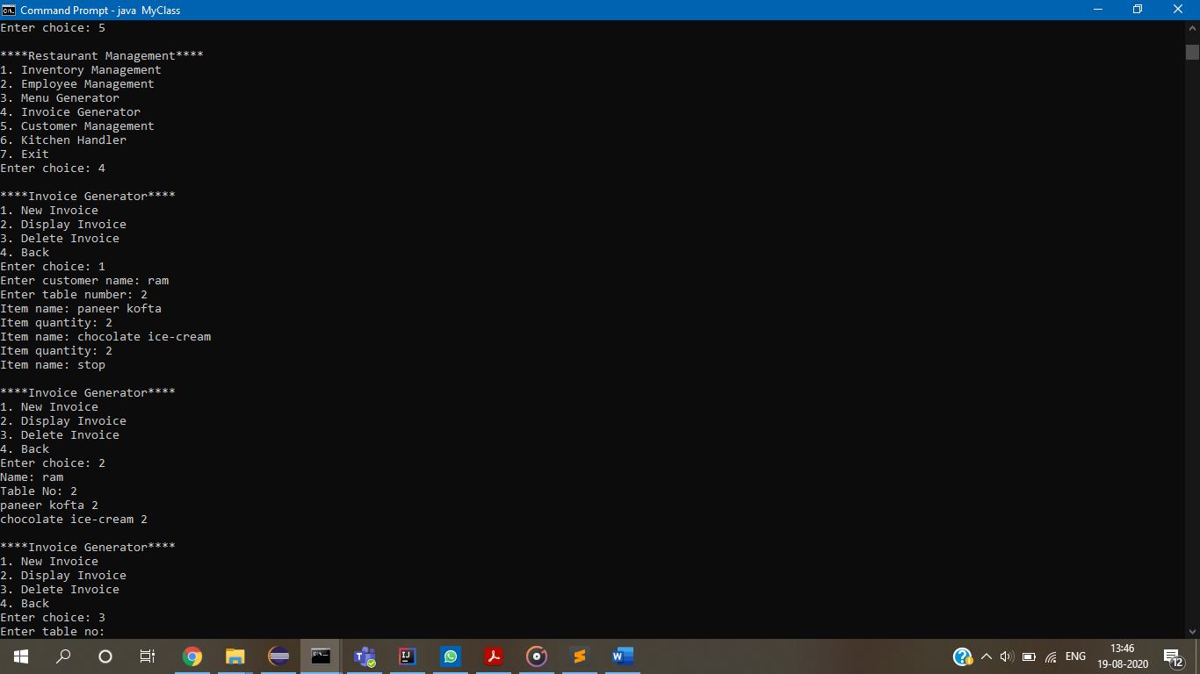

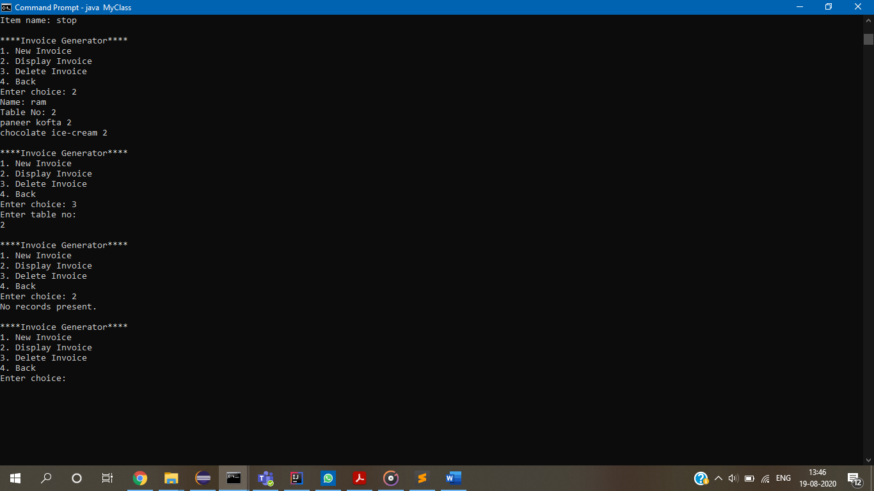

Menu Generator:

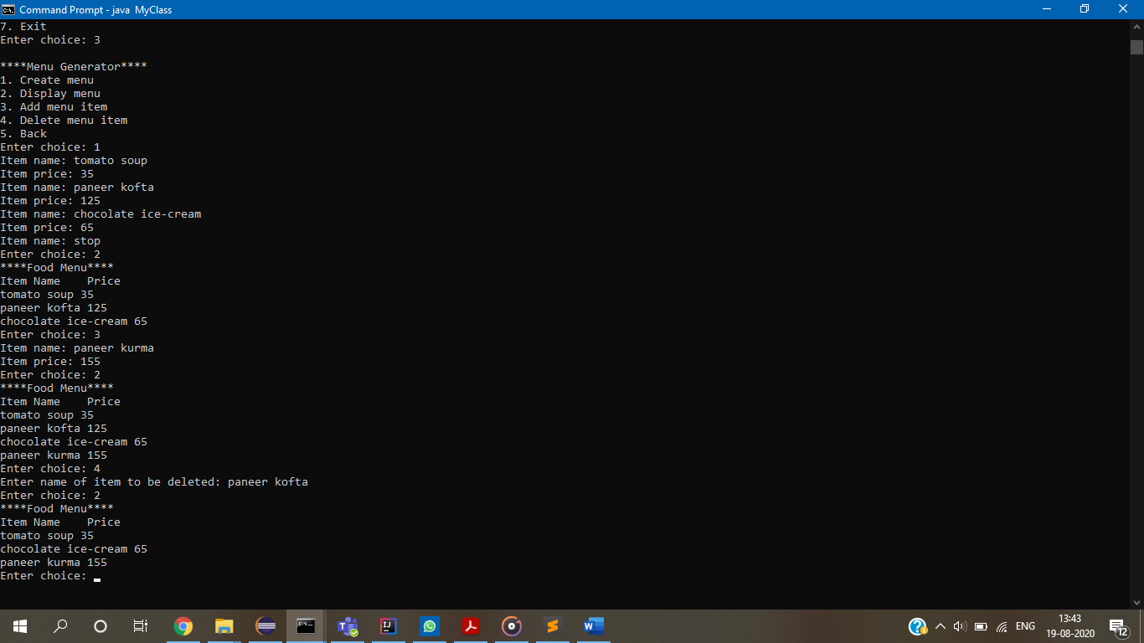

Customer Management:

